Halton Educational Psychology Service

Normal Responses to difficult situations information for Children and Young People

Normal responses to difficult situations:

Everyone reacts differently to stress and anxiety. Responses vary according to the level of stress experienced, our ability to bounce back (resilience), our coping mechanisms and our previous experiences. Normal reactions can include¹:

- feeling as if you are in a state of ‘high alert’ and are ‘on edge’ for anything else that might happen
- feeling emotionally numb, as if in a state of ‘shock’
- becoming emotional and upset
- feeling extremely fatigued and tired
- feeling very stressed and/or anxious
- being very protective of others including family and friends
- Not wanting to leave a particular place for fear of ‘what might happen’.

Long term experiences of stress and anxiety can lead to difficulties with:

- sleep,
- appetite (increased or reduced)
- Mood swings.
- a lack of concentration
- difficulty finishing tasks
- Reduction in productivity.

All of these responses in the short term could be viewed as normal and in the current circumstances expected. As you return to school or College, some will be glad to be back. Others will struggle to return and experience anxiety about their health and the health of others. Some will feel a sense of loss leaving their families as they will have enjoyed the time at home. Others will have found the time difficult, relationships may have suffered or changed significantly. We have all experienced the same storm but the boat we have sailed in is ours alone and everyone’s experiences will be different.

Normal responses of grief and loss and higher than usual stress and anxiety are to be expected. If you were in year 11 or year 13 it is normal to feel concerned or worried about the future. It is normal to have these feelings anyway AND it is likely you will feel these even more in the current circumstances. It is okay not to know what is going to happen. You can make a decision to make NO DECISIONS about the future for now.

If you or your child are experiencing difficulties then the first action you can take is to talk with staff at your child’s school for more help and support.

Other things that may be helpful can include:

Practical strategies to help manage your feelings

- Relaxed breathing

- Breathe in slowly and steadily through your nose for a count of 4 - don’t rush this!
- Pause for a count of 1
- Exhale slowly and steadily for a count of 4 - breathe out gradually - try not to breathe out with a sigh
- Repeat for a few minutes until you notice a change in how your body feels
- If you get distracted, or if your mind wanders, just bring your attention back to how it feels to breathe in and out
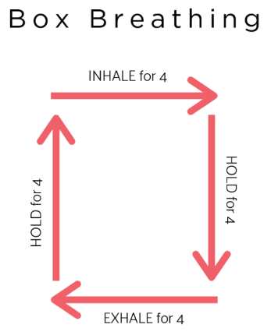

- Being Mindful

- Notice the thought and ask yourself whether it is helpful for you and whether it will lead you towards the values you have in your life.
- Sitting with the thought and saying to yourself “I am having the thought that...”
- Thank your mind for that thought – “Thank you mind, how very informative!” or “is that right? How fascinating!” or simply “Thanks, Mind!” The spirit here is to not take your thoughts too seriously; or get into a struggle with them.
- Say the thought in your head with a funny voice e.g. Homer Simpson.
- Sing the thought out loud.
- Mindful watching-Imagine you are on top of the mountain, with some steady rocks underneath your feet and a whole landscape in front of you. Inhale the mountain breeze. Then pay attention to your thoughts and imagine you put each single one on clouds and send them to the sky. You can do that until you feel your mind is slower and emptier of thoughts.
- Write down the thoughts on a piece of paper to see them from a different perspective.
- Naming the story- if all these thoughts and feelings were put into a book or movie, titled ‘the something something story’, what would you call it? Each time this story shows up name it, ‘ahh there’s the XYZ story again!’
- Computer screen- imagine this thought on a computer screen. Change the font, colour and format. Animate the words. Add in a bouncing ball.
- Learn more and practice mindfulness so that you can be aware of when you are in the present moment rather than being 'in your head' and thinking about the past or worrying about the future. Notice what you don't normally notice - sights, sounds, sensations, thoughts, textures etc.

- BEING IN THE NOW:

- Say 5 things you can see right now
- Say 4 things you can hear right now
- Say 3 things you can touch, and reach out and touch them, right now
- Say 2 things you can smell or like the smell of
- Take 1 slow, deep breath. Then focus on your breathing, before shifting your focus of attention onto something different...
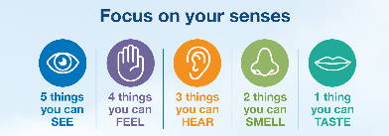

FREE Apps to help you be mindful

Smiling Mind and Stop, Breathe & Think both available via google play or the app store

Other self-care ideas that can really help include:

- talking to others
- Leading a healthy balanced lifestyle; eating well, getting enough sleep and being physically active
- routines
- seeking help when it is needed
- taking down time
- meditation
- hobbies
For more self-care ideas visit: https://www.annafreud.org/on-my-mind/self-care/

When to seek help?

It is important to recognise when normal responses become too difficult to cope with. For Example

- If feelings of stress and anxiety do not settle within a month or two (whilst the new normal is being adapted to) despite helpful self-care strategies in place, and if it is combined with strategies to cope that include drug use, alcohol misuse, difficulty eating and sleeping or significant irritability and /or low mood that last a long time, GET SOME HELP

This advice is on a case by case basis and there are no hard and fast rules. Factors to be considered may also include difficulties with mental health before the pandemic, substance misuse, death or bereavement of a loved one prior to or during the pandemic. Remember everyone is different!

Help available for children and young people:

For details of support available in Halton visit www.halton.gov.uk/mhinfopoint
If you are a young person experiencing a mental health crisis, you can text the Young Minds Crisis Messenger for free, 24/7 support text YM to 85258.

